1. Dataset plot
In this problem, we use the fetch_20newsgroups dataset from sklearn package to plot the number of training documents per class.
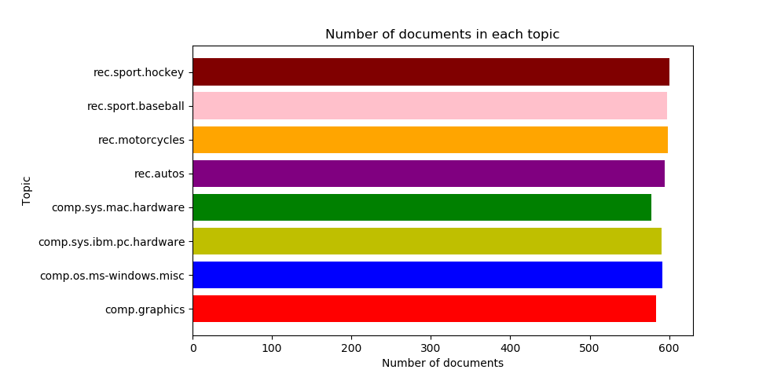
From the figure above, we could see that the data set is already balanced and in every class the number of documents is almost equivalent.

2. Create TF*IDF vector representation

A popular numerical statistic to capture the importance of a word is TFxIDF metric. This measure takes into account the words in the document. The discriminating words will most likely be those that are specialized terms describing different types of accessories and hence will occur in fewer documents.
In this problem, we need to convert the documents of 8 classes into numerical feature vectors. Firstly, we use ‘snowball’ to remove morphological affixes from words. After that, we remove all punctuation, all symbols and non-ascii characters. We used TfidfTransformer to calculate TFIDF, where tf(t, d) represents the frequency of term t in document d, and inverse document frequency is defined as: idf(t) = log [ n / df(t)] + 1 and df(t) is the document frequency; the document frequency is the number of documents that contain the term t.

Token shape: (1175, 11908) [min_df = 2, enable_stopword = True, enable_stem = True]

TFxIDF shape: (1175, 11908) [min_df = 2, enable_stopword = True, enable_stem = True]

[min_df = 2] Number of terms: 11908

Token shape: (1175, 4304) [min_df = 5, enable_stopword = True, enable_stem = True]

TFxIDF shape: (1175, 4304) [min_df = 5, enable_stopword = True, enable_stem = True]

[min_df = 5] Number of terms: 4304

3. Calculate the TF*ICF
In order to quantify how significant a word is to a class, we calculate TFxICF. It is the same as TFxIDF, except that a class sits in place of a document; that is for a term t and a class c. And we need to find the 10 most significant terms in each of the 4 classes with respect to TFICF measure.

comp.sys.ibm.pc.hardware [u'scsi', u'drive', u'edu', u'ide', u'line', u'use', u'com', u'subject', u'organization', u'controller']

comp.sys.mac.hardware [u'edu', u'line', u'mac', u'subject', u'organization', u'apple', u'use', u'quadra', u'scsi', u'problem']

misc.forsale [u'edu', u'line', u'sale', u'subject', u'organization', u'new', u'post', u'com', u'university', u'offer']

soc.religion.christian [u'god', u'edu', u'christian', u'jesus', u'say', u'church', u'subject', u'people', u'line', u'know']

4. In this problem, we need to transform the data’s dimensional into a lower dimensional space. We use Latent Semantic Indexing (LSI) and NMF to lower the space into 50. As to LSI, we used the SVD decomposition to obtain left and right singular vectors and then get a lower space.

Token shape: (4732, 24849) [min_df = 2, enable_stopword = True, enable_stem = True]

TFxIDF shape: (4732, 24849) [min_df = 2, enable_stopword = True, enable_stem = True]

Shape of feature vec after LSI: (4732, 50)

Shape of feature vec after NMF: (4732, 50)

5. In next parts, we need to classify the documents into two categories ‘‘Computer Technology’ vs ‘Recreational Activity’. We need to combine documents of sub-classes of each class to form the set of documents for each class. And we need to assess the model by precision, recall and ROC curve.
In this part, based on LSI and NMF,we used SVM to make classification.

1) Hard- SVM with LSI

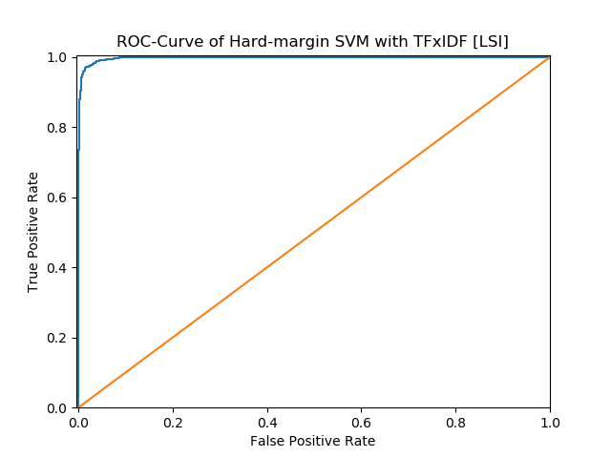

 | Precision | Recall | Accuracy
Computer technology | 0.9938 | 0.9295 | 0.9622
Recreational activity | 0.9349 | 0.9943 | 0.9622
Average | 0.9619 | 0.9644 | 0.9622

 | TP | FP | FN | TN
Computer technology | 1450 | 9 | 110 | 1581
Recreational activity | 1581 | 110 | 9 | 1450

We set computer technology as positive and recreational activity as negative to construct the confusion matrix as follow:

 | Ground Truth | Ground False
Predicted positive | 1450 | 9
Predicted negative | 110 | 1581

2) Hard- SVM with NMF
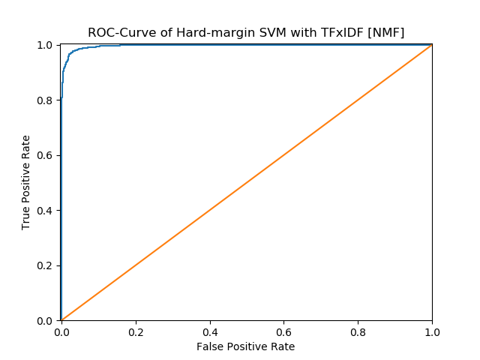

 | Precision | Recall | Accuracy
Computer technology | 0.9916 | 0.9090 | 0.9511
Recreational activity | 0.9174 | 0.9925 | 0.9511
Average | 0.9507 | 0.9545 | 0.9511

 | TP | FP | FN | TN
Computer technology | 1418 | 12 | 142 | 1578
Recreational activity | 1578 | 142 | 12 | 1418

We set computer technology as positive and recreational activity as negative to construct the confusion matrix as follow:
 | Ground Truth | Ground False
Predicted positive | 1418 | 12
Predicted negative | 142 | 1578

3) Soft- SVM with LSI
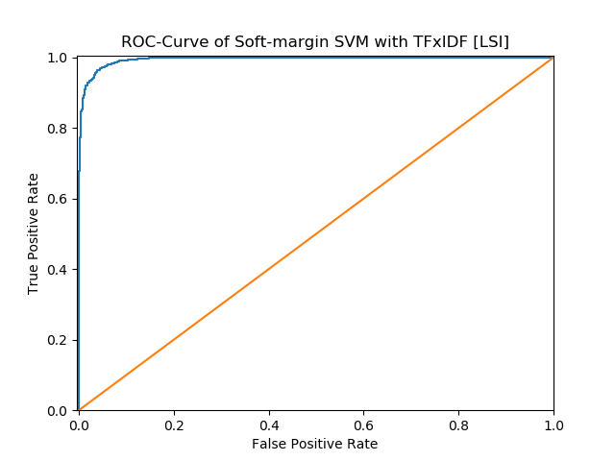

 | Precision | Recall | Accuracy
Computer technology | 0.9922 | 0.8917 | 0.9429
Recreational activity | 0.9033 | 0.9931 | 0.9429
Average | 0.9424 | 0.9477 | 0.9429

 | TP | FP | FN | TN
Computer technology | 1391 | 11 | 169 | 1579
Recreational activity | 1579 | 169 | 11 | 1391
We set computer technology as positive and recreational activity as negative to construct the confusion matrix as follow:
 | Ground Truth | Ground False
Predicted positive | 1391 | 11
Predicted negative | 169 | 1579
4) Soft- SVM with NMF
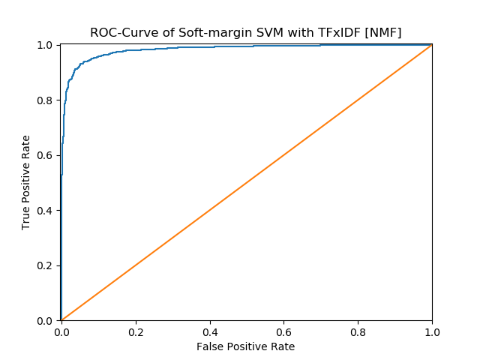

 | Precision | Recall | Accuracy
Computer technology | 1.0000 | 0.0410 | 0.5251
Recreational activity | 0.5152 | 1.0000 | 0.5251
Average | 0.5205 | 0.7576 | 0.5251

 | TP | FP | FN | TN
Computer technology | 64 | 0 | 1496 | 1590
Recreational activity | 1590 | 1496 | 0 | 64
We set computer technology as positive and recreational activity as negative to construct the confusion matrix as follow:
 | Ground Truth | Ground False
Predicted positive | 64 | 0
Predicted negative | 1496 | 1590
python main.py --task f git pull origin master

6. In this part, we use 5-fold cross-validation to find the parameter γ and report the confusion matrix and accuracy,recall and precision.

[gamma = 0.001] 5-Fold Average Accuracy: 0.94421304
[gamma = 0.01] 5-Fold Average Accuracy: 0.96745837
[gamma = 0.1] 5-Fold Average Accuracy: 0.96999537
[gamma = 1.0] 5-Fold Average Accuracy: 0.97591124
[gamma = 10] 5-Fold Average Accuracy: 0.97654459
[gamma = 100] 5-Fold Average Accuracy: 0.97569870
[gamma = 1000] 5-Fold Average Accuracy: 0.97379774
Best Accuracy is 0.97654459 when gamma = 10

SVM with TFxIDF [LSI]
 | Precision | Recall | Accuracy
Computer technology | 0.9818 | 0.9679 | 0.9752
Recreational activity | 0.9690 | 0.9824 | 0.9752
Average | 0.9752 | 0.9754 | 0.9752

 | TP | FP | FN | TN
Computer technology | 1510 | 28 | 50 | 1562
Recreational activity | 1562 | 50 | 28 | 1510
We set computer technology as positive and recreational activity as negative to construct the confusion matrix as follow:
 | Ground Truth | Ground False
Predicted positive | 1510 | 28
Predicted negative | 50 | 1562

SVM with TFxIDF [NMF]

 | Precision | Recall | Accuracy
Computer technology | 0.9738 | 0.9538 | 0.9644
Recreational activity | 0.9556 | 0.9748 | 0.9644
Average | 0.9643 | 0.9647 | 0.9644

 | TP | FP | FN | TN
Computer technology | 1488 | 40 | 72 | 1550
Recreational activity | 1550 | 72 | 40 | 1488
We set computer technology as positive and recreational activity as negative to construct the confusion matrix as follow:
 | Ground Truth | Ground False
Predicted positive | 1488 | 40
Predicted negative | 72 | 1550

7. Next, we use naïve Bayes algorithm for the same classification task.
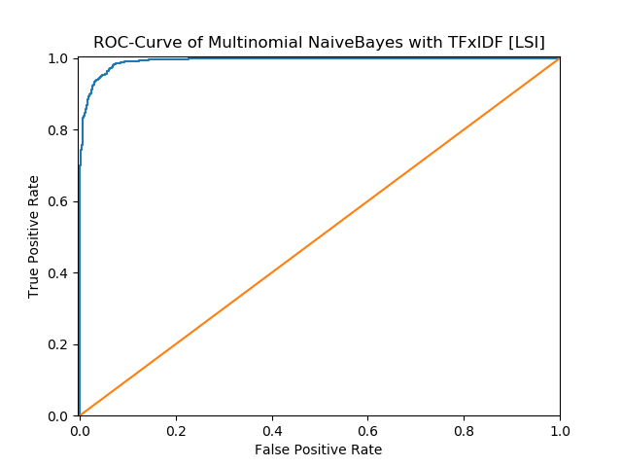

 | Precision | Recall | Accuracy
Computer technology | 0.9927 | 0.8718 | 0.9333
Recreational activity | 0.8876 | 0.9937 | 0.9333
Average | 0.9328 | 0.9402 | 0.9333

 | TP | FP | FN | TN
Computer technology | 1360 | 10 | 200 | 1580
Recreational activity | 1580 | 200 | 10 | 1360
We set computer technology as positive and recreational activity as negative to construct the confusion matrix as follow:
 | Ground Truth | Ground False
Predicted positive | 1360 | 10
Predicted negative | 200 | 1580

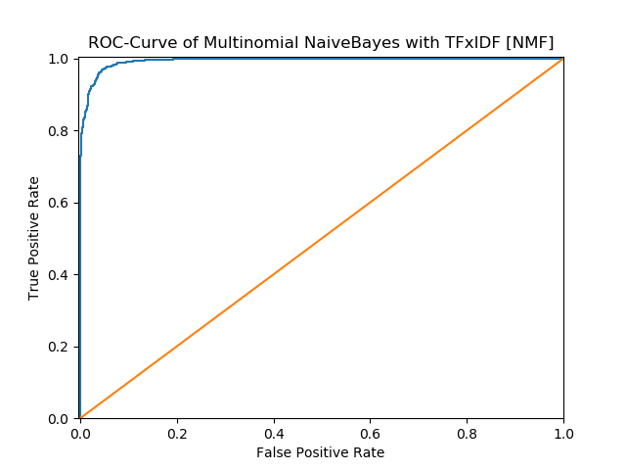

 | Precision | Recall | Accuracy
Computer technology | 0.9773 | 0.9397 | 0.9594
Recreational activity | 0.9430 | 0.9786 | 0.9594
Average | 0.9592 | 0.9602 | 0.9594

 | TP | FP | FN | TN
Computer technology | 1466 | 34 | 94 | 1556
Recreational activity | 1556 | 94 | 34 | 1466
We set computer technology as positive and recreational activity as negative to construct the confusion matrix as follow:
 | Ground Truth | Ground False
Predicted positive | 1466 | 34
Predicted negative | 94 | 1556

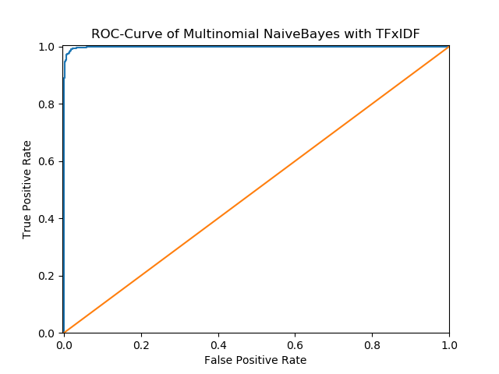

 | Precision | Recall | Accuracy
Computer technology | 0.9890 | 0.9814 | 0.9854
Recreational activity | 0.9819 | 0.9893 | 0.9854
Average | 0.9854 | 0.9855 | 0.9854

 | TP | FP | FN | TN
Computer technology | 1531 | 17 | 29 | 1573
Recreational activity | 1573 | 29 | 17 | 1531

We set computer technology as positive and recreational activity as negative to construct the confusion matrix as follow:
 | Ground Truth | Ground False
Predicted positive | 1531 | 17
Predicted negative | 29 | 1573

8. Repeat the same task with the logistic regression classifier, and plot the ROC curve.
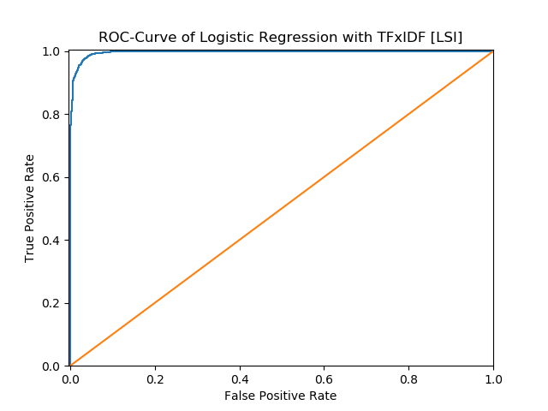

 | Precision | Recall | Accuracy
Computer technology | 0.9804 | 0.9603 | 0.9708
Recreational activity | 0.9618 | 0.9811 | 0.9708
Average | 0.9707 | 0.9711 | 0.9708

 | TP | FP | FN | TN
Computer technology | 1498 | 30 | 62 | 1560
Recreational activity | 1560 | 62 | 30 | 1498

We set computer technology as positive and recreational activity as negative to construct the confusion matrix as follow:
 | Ground Truth | Ground False
Predicted positive | 1498 | 30
Predicted negative | 62 | 1560

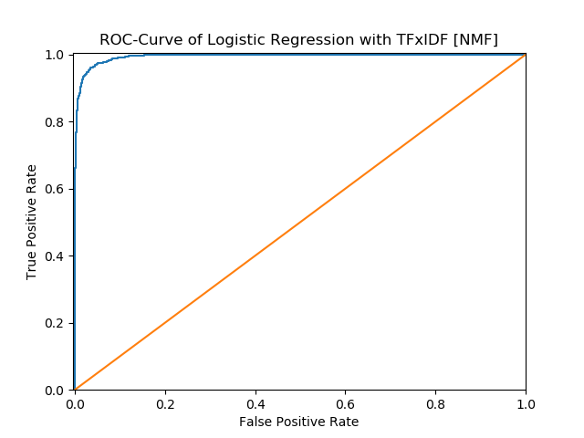

 | Precision | Recall | Accuracy
Computer technology | 0.9657 | 0.9551 | 0.9610
Recreational activity | 0.9564 | 0.9667 | 0.9610
Average | 0.9609 | 0.9610 | 0.9610

 | TP | FP | FN | TN
Computer technology | 1490 | 53 | 70 | 1573
Recreational activity | 1537 | 70 | 53 | 1490

We set computer technology as positive and recreational activity as negative to construct the confusion matrix as follow:
 | Ground Truth | Ground False
Predicted positive | 1490 | 53
Predicted negative | 70 | 1537

9. Now, by adding a regularization term to the optimization objective. Try both l 1 and l 2 norm regularizations and sweep through different regularization coefficients, ranging from very small ones to large ones. How does the regularization parameter affect the test error? How are the coefficients of the fitted hyperplane affected? Why might one be interested in each type of
regularization?

************************************************************
* [C = 0.001] L1-Logistic Regression with TFxIDF [LSI]
************************************************************
Precision Recall Accuracy
Computer technology 0.4952 1.0000 0.4952
Recreational activity 0.0000 0.0000 0.4952
Average 0.5000 0.2476 0.4952
------------------------------------------------------------
TP FP FN TN
Computer technology 1560 1590 0 0
Recreational activity 0 0 1590 1560
------------------------------------------------------------
************************************************************
* [C = 0.001] L1-Logistic Regression with TFxIDF [NMF]
************************************************************
Precision Recall Accuracy
Computer technology 0.4952 1.0000 0.4952
Recreational activity 0.0000 0.0000 0.4952
Average 0.5000 0.2476 0.4952
------------------------------------------------------------
TP FP FN TN
Computer technology 1560 1590 0 0
Recreational activity 0 0 1590 1560
------------------------------------------------------------
************************************************************
* [C = 0.001] L2-Logistic Regression with TFxIDF [LSI]
************************************************************
Precision Recall Accuracy
Computer technology 1.0000 0.5474 0.7759
Recreational activity 0.6925 1.0000 0.7759
Average 0.7737 0.8463 0.7759
------------------------------------------------------------
TP FP FN TN
Computer technology 854 0 706 1590
Recreational activity 1590 706 0 854
------------------------------------------------------------
************************************************************
* [C = 0.001] L2-Logistic Regression with TFxIDF [NMF]
************************************************************
Precision Recall Accuracy
Computer technology 0.0000 0.0000 0.5048
Recreational activity 0.5048 1.0000 0.5048
Average 0.5000 0.2524 0.5048
------------------------------------------------------------
TP FP FN TN
Computer technology 0 0 1560 1590
Recreational activity 1590 1560 0 0
------------------------------------------------------------
************************************************************
* [C = 0.01] L1-Logistic Regression with TFxIDF [LSI]
************************************************************
Precision Recall Accuracy
Computer technology 0.9256 0.9173 0.9225
Recreational activity 0.9196 0.9277 0.9225
Average 0.9225 0.9226 0.9225
------------------------------------------------------------
TP FP FN TN
Computer technology 1431 115 129 1475
Recreational activity 1475 129 115 1431
------------------------------------------------------------
************************************************************
* [C = 0.01] L1-Logistic Regression with TFxIDF [NMF]
************************************************************
Precision Recall Accuracy
Computer technology 0.4952 1.0000 0.4952
Recreational activity 0.0000 0.0000 0.4952
Average 0.5000 0.2476 0.4952
------------------------------------------------------------
TP FP FN TN
Computer technology 1560 1590 0 0
Recreational activity 0 0 1590 1560
------------------------------------------------------------
************************************************************
* [C = 0.01] L2-Logistic Regression with TFxIDF [LSI]
************************************************************
Precision Recall Accuracy
Computer technology 0.9909 0.9038 0.9483
Recreational activity 0.9131 0.9918 0.9483
Average 0.9478 0.9520 0.9483
------------------------------------------------------------
TP FP FN TN
Computer technology 1410 13 150 1577
Recreational activity 1577 150 13 1410
------------------------------------------------------------
************************************************************
* [C = 0.01] L2-Logistic Regression with TFxIDF [NMF]
************************************************************
Precision Recall Accuracy
Computer technology 1.0000 0.0635 0.5362
Recreational activity 0.5211 1.0000 0.5362
Average 0.5317 0.7606 0.5362
------------------------------------------------------------
TP FP FN TN
Computer technology 99 0 1461 1590
Recreational activity 1590 1461 0 99
------------------------------------------------------------
************************************************************
* [C = 0.1] L1-Logistic Regression with TFxIDF [LSI]
************************************************************
Precision Recall Accuracy
Computer technology 0.9555 0.9231 0.9406
Recreational activity 0.9270 0.9579 0.9406
Average 0.9405 0.9413 0.9406
------------------------------------------------------------
TP FP FN TN
Computer technology 1440 67 120 1523
Recreational activity 1523 120 67 1440
------------------------------------------------------------
************************************************************
* [C = 0.1] L1-Logistic Regression with TFxIDF [NMF]
************************************************************
Precision Recall Accuracy
Computer technology 0.8462 0.5045 0.7092
Recreational activity 0.6518 0.9101 0.7092
Average 0.7073 0.7490 0.7092
------------------------------------------------------------
TP FP FN TN
Computer technology 787 143 773 1447
Recreational activity 1447 773 143 787
------------------------------------------------------------
************************************************************
* [C = 0.1] L2-Logistic Regression with TFxIDF [LSI]
************************************************************
Precision Recall Accuracy
Computer technology 0.9769 0.9468 0.9625
Recreational activity 0.9493 0.9780 0.9625
Average 0.9624 0.9631 0.9625
------------------------------------------------------------
TP FP FN TN
Computer technology 1477 35 83 1555
Recreational activity 1555 83 35 1477
------------------------------------------------------------
************************************************************
* [C = 0.1] L2-Logistic Regression with TFxIDF [NMF]
************************************************************
Precision Recall Accuracy
Computer technology 0.9784 0.8128 0.8984
Recreational activity 0.8425 0.9824 0.8984
Average 0.8976 0.9104 0.8984
------------------------------------------------------------
TP FP FN TN
Computer technology 1268 28 292 1562
Recreational activity 1562 292 28 1268
------------------------------------------------------------
************************************************************
* [C = 1] L1-Logistic Regression with TFxIDF [LSI]
************************************************************
Precision Recall Accuracy
Computer technology 0.9804 0.9603 0.9708
Recreational activity 0.9618 0.9811 0.9708
Average 0.9707 0.9711 0.9708
------------------------------------------------------------
TP FP FN TN
Computer technology 1498 30 62 1560
Recreational activity 1560 62 30 1498
------------------------------------------------------------
************************************************************
* [C = 1] L1-Logistic Regression with TFxIDF [NMF]
************************************************************
Precision Recall Accuracy
Computer technology 0.9657 0.9551 0.9610
Recreational activity 0.9564 0.9667 0.9610
Average 0.9609 0.9610 0.9610
------------------------------------------------------------
TP FP FN TN
Computer technology 1490 53 70 1537
Recreational activity 1537 70 53 1490
------------------------------------------------------------
************************************************************
* [C = 1] L2-Logistic Regression with TFxIDF [LSI]
************************************************************
Precision Recall Accuracy
Computer technology 0.9764 0.9564 0.9670
Recreational activity 0.9581 0.9774 0.9670
Average 0.9669 0.9673 0.9670
------------------------------------------------------------
TP FP FN TN
Computer technology 1492 36 68 1554
Recreational activity 1554 68 36 1492
------------------------------------------------------------
************************************************************
* [C = 1] L2-Logistic Regression with TFxIDF [NMF]
************************************************************
Precision Recall Accuracy
Computer technology 0.9587 0.9224 0.9419
Recreational activity 0.9266 0.9610 0.9419
Average 0.9417 0.9427 0.9419
------------------------------------------------------------
TP FP FN TN
Computer technology 1439 62 121 1528
Recreational activity 1528 121 62 1439
------------------------------------------------------------
************************************************************
* [C = 10] L1-Logistic Regression with TFxIDF [LSI]
************************************************************
Precision Recall Accuracy
Computer technology 0.9817 0.9654 0.9740
Recreational activity 0.9666 0.9824 0.9740
Average 0.9739 0.9742 0.9740
------------------------------------------------------------
TP FP FN TN
Computer technology 1506 28 54 1562
Recreational activity 1562 54 28 1506
------------------------------------------------------------
************************************************************
* [C = 10] L1-Logistic Regression with TFxIDF [NMF]
************************************************************
Precision Recall Accuracy
Computer technology 0.9790 0.9551 0.9676
Recreational activity 0.9570 0.9799 0.9676
Average 0.9675 0.9680 0.9676
------------------------------------------------------------
TP FP FN TN
Computer technology 1490 32 70 1558
Recreational activity 1558 70 32 1490
------------------------------------------------------------
************************************************************
* [C = 10] L2-Logistic Regression with TFxIDF [LSI]
************************************************************
Precision Recall Accuracy
Computer technology 0.9817 0.9635 0.9730
Recreational activity 0.9648 0.9824 0.9730
Average 0.9729 0.9733 0.9730
------------------------------------------------------------
TP FP FN TN
Computer technology 1503 28 57 1562
Recreational activity 1562 57 28 1503
------------------------------------------------------------
************************************************************
* [C = 10] L2-Logistic Regression with TFxIDF [NMF]
************************************************************
Precision Recall Accuracy
Computer technology 0.9659 0.9455 0.9565
Recreational activity 0.9476 0.9673 0.9565
Average 0.9564 0.9568 0.9565
------------------------------------------------------------
TP FP FN TN
Computer technology 1475 52 85 1538
Recreational activity 1538 85 52 1475

